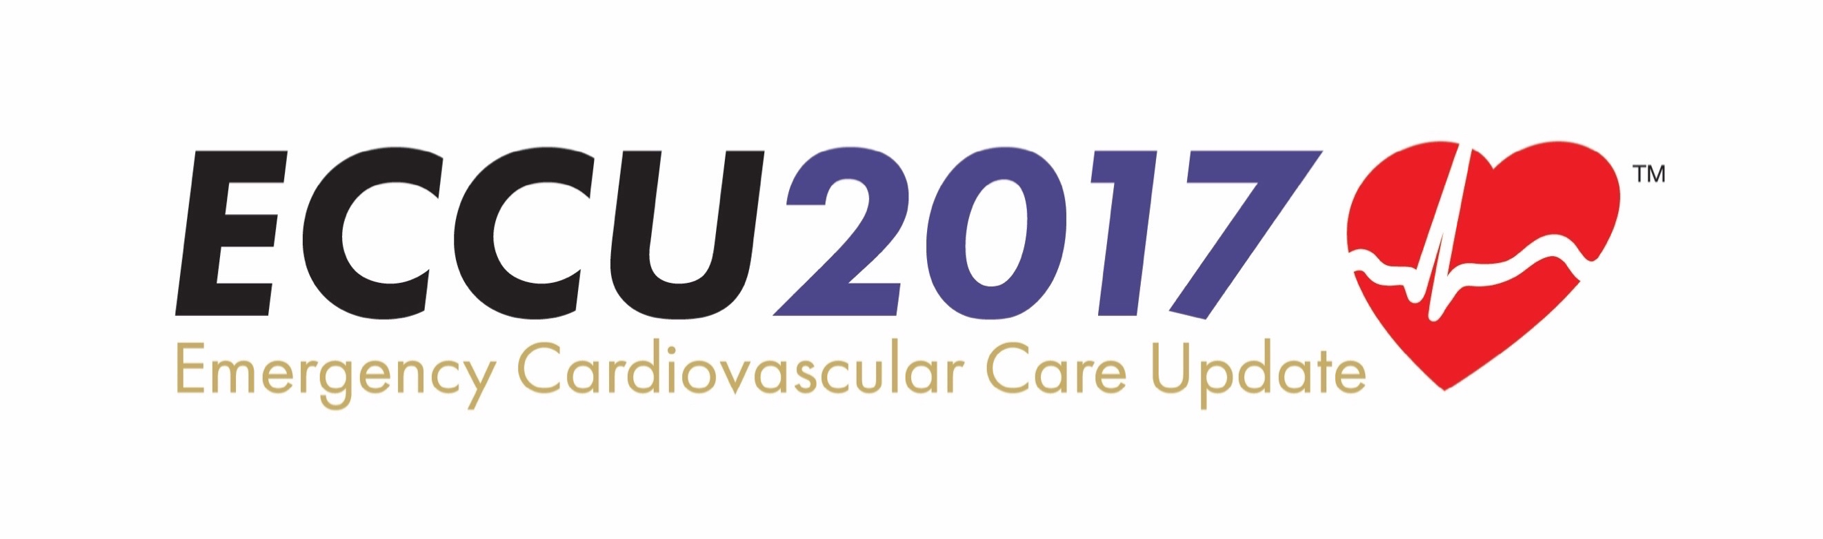

PulsePoint Community Grant Application

PulsePoint Foundation and the Citizen CPR Foundation join forces to bring a first-of-its-kind grant competition to the Emergency Cardiovascular Care Update (ECCU) Conference in New Orleans, December 5-8, 2017.

The grant includes a complete PulsePoint Respond implementation, including first year costs (valued at over $20,000), to be awarded to a community that demonstrates commitment to improving care and outcomes consistent with the mission of the Citizen CPR Foundation. The award-winning PulsePoint mobile app, now in more than 2,200 communities nationwide, alerts CPR-trained citizens of cardiac events in their vicinity so they may administer aid, and informs responders and emergency dispatchers of nearby Automated External Defibrillators (AEDs).

Interested communities and representatives are encouraged to learn more and submit an entry. Three finalist communities will be selected in advance of the ECCU Conference and invited to present their entries during the plenary session at ECCU 2017 entitled: Innovation and Resuscitation – Leveraging Digital Strategies to Improve Survival Rates from SCA. Judges will interact with the finalists on stage to review the merits of their entries and ultimately will present the award to the community that scores highest. This is an extraordinary opportunity for public safety agencies to acquire the latest technology to improve cardiac arrest outcomes with a minimal initial investment.

Grant Requirements

- Completion (live) within 180 days of award.
- Standard PulsePoint implementation (Standard SOW, Terms and Conditions).
- Agency is responsible for ongoing costs after year one.
- Finalists are responsible for costs associated with travel and attendance at the conference.

Submission Requirements

- Submit completed applications to [need ECCU email address]?
- Applications must be received no later than September 1, 2017.

Submissions will be judged based on responses to the questions below. 100 points are possible, as scored by the ECCU judges.

Agency and Point of Contact

Please indicate the primary point of contact between the agency and ECCU staff for grant related communications.

Agency

Name

Title

Email

Phone

Describe your agency, community served and dispatch environment.
(At a minimum, include cities/communities served, population served, dispatch system vendor, EMD software vendor and if you are a Police/Fire/EMS dispatch center. If you do not use EMD software, describe how you identify cardiac arrest incidents, i.e. nature/event code.)

Demonstration of a strong commitment to the Chain of Survival (25 Points)
(Describe citizen CPR initiatives, mass training events, CPR days, school programs, AED promotion and Public Access Defibrillator programs, AED location efforts, etc.)

Leadership commitment to implement PulsePoint (10 Points)
(Describe leadership/management and key stakeholder support for the implementation of PulsePoint in your organization)

Identification and introduction of a PulsePoint project lead (10 Points)
(Tell us about the project lead in your organization who will have the assigned responsibility for the implementation of PulsePoint)

Demonstration of broad stakeholder backing including key letters of support (10 Points)
(Please include letters of support from all key stakeholders. Typical stakeholders in PulsePoint implementations include the dispatch center manager, IT manager, Fire/EMS chief and Medical Director.)

Readiness to implement within a reasonable timeframe after award (10 Points)
(Tell us what steps you have taken to ensure that the project can begin promptly after award. This includes the technical integration, AED registry formation, and outreach/launch planning).

Evidence of success with other community-wide programs of similar scope (10 Points)
(Please provide examples of community projects of similar scale that your organization has successfully undertaken.)

Overview of community outreach planned to encourage adoption and use (10 Points)
(Please tell us how you plan to engage your community and message CPR trained citizens about PulsePoint)

Acknowledgement of technical requirements for use of PulsePoint (5 Points)
(Please acknowledge that you have read and understand the PulsePoint Implementation Guide, and understand the technical requirements to implement. If your CAD system is not from a PulsePoint Preferred Vendor (see http://www.pulsepoint.org/implementation/#cad ) please reach out to PulsePoint (info@pulsepoint.org) to discuss any special requirements that will need to be detailed here.)

Willingness to continue PulsePoint beyond initial award period (10 Points)
(This grant is for a complete implementation, including first year licensing costs. Describe your willingness and ability to continue PulsePoint service beyond the grant term. Pricing information can be found here http://www.pulsepoint.org/implementation).

